- Visualisation
  - Appropriate graphs for the RQ output of an R script (NOT a screenshot) (50 words)

Boxplot shows that caesarean groups have same amount of lung capacity and doesn’t show large difference in middle value.

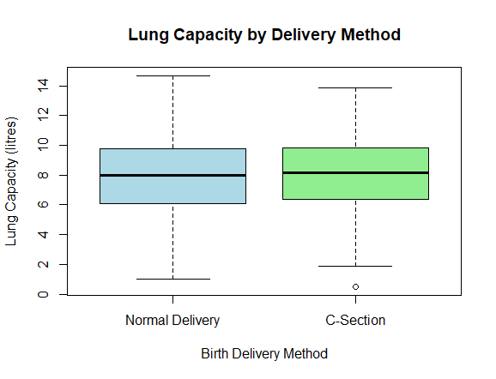

Histogram shows that the graph follows normal distribution cure. It helps us to understand the data distribution and its patten. It will also help us to select the appropriate statistical test.

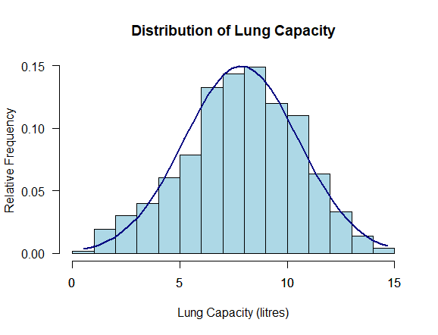

  - Additional information relating to understanding the data (optional) (50 words)

The boxplot shows that there is similar variability in the lung capacity of the two delivery groups(caesarean), and there is little variation in their central tendency values. The histogram shows that the data is not following a normal pattern, but the pattern is smooth. The two graphical tools work well together to provide a first insight into the data pattern before performing the test.

  - Useful information for the data understanding (50 words)

The mean and median values of the two birth groups seem to be quite similar and shows smaller differences in the lung capacity. Histogram also indicates that the values are spread out but in limitations. All these patten shows that the discrepancies in the groups could be quite small and need statistical test for proof.

- Analysis
  - Statistical test used to test the hypotheses and output (75 words)

The independent t-test is used to find any differences for lung capacity exists in the normal and C-section deliveries. The t-test is applicable in this case because the question focuses on comparing the average values(dependent) in the two independent samples. The data in the histogram shows normally distributed curve, with the help of t-test we will be able to determining the difference in values is because of meaningful reason or natural difference.

  - The null hypothesis is rejected /not rejected based on the p-value (100 words)

The p-value in the t-test is 0.564, which is way above the significance level of 0.05. Thus, we fail to reject the null hypothesis. We have not found evidence to prove that the value of lung capacity differs in the normal and C-section births. The variation in the averages is nothing but a matter of random chance, and the conclusion to be derived is that the type of delivery has nothing to do with the capacity of the lungs in this sample, however the difference in lung capacity can be because of many other known or unknown reasons.

- Reference list (not included in the word count)
Harvard (author, date) format.

Dojo Staff, D.S. (2022). 7 Types of Statistical Distributions with Practical Examples. Datasciencedojo. Available at: https://datasciencedojo.com/blog/types-of-statistical-distributions-in-ml/ [Accessed 7 Dec. 2025].

- Appendices

library(readr)
library(readxl)

LungCapData <- read_csv("LungCapData.csv")
View(LungCapData)

#reading columns and rows
colnames(LungCapData)
nrow(LungCapData)

#Changing Caesarean from yes & no to C-Section & Normal Delivery
LungCapData$Caesarean[is.na(LungCapData$Caesarean)] <- "no"

LungCapData$Caesarean[LungCapData$Caesarean == "no"] <- 0
LungCapData$Caesarean[LungCapData$Caesarean == "yes"] <- 1

LungCapData$Caesarean <- as.numeric(LungCapData$Caesarean)

LungCapData$Caesarean <- factor(
LungCapData$Caesarean,
levels = c(0, 1),
labels = c("Normal Delivery", "C-Section")
)

#Reading updated rows
table(LungCapData$Caesarean)
table(LungCapData$Smoke)
table(LungCapData$Gender)

#reading first 5 rows
head(LungCapData, 5)

#Analyzing bit
summary(LungCapData$LungCap)
summary(LungCapData$Caesarean)
sd(LungCapData$LungCap)
sd(LungCapData$Age)
mean(LungCapData$LungCap)
median(LungCapData$LungCap)

# Mean of Lung Capacity by delivery method
aggregate(LungCap ~ Caesarean, data = LungCapData, FUN = mean)

# Median of Lung Capacity by delivery method
aggregate(LungCap ~ Caesarean, data = LungCapData, FUN = median)

#Boxplot (comparison of means)
boxplot(LungCap ~ Caesarean,
data = LungCapData,
main = "Lung Capacity by Delivery Method",
xlab = "Birth Delivery Method",
ylab = "Lung Capacity (litres)",
col = c("lightblue", "lightgreen"))

#Histogram (comparison of means)
hist(LungCapData$LungCap,
prob = T,
breaks=20,
xlab = "Lung Capacity (litres)",
ylab = "Relative Frequency",
main = "Distribution of Lung Capacity",
col = "lightblue",
las = 1)
axis(side = 1
)
x <- seq(min(LungCapData$LungCap), max(LungCapData$LungCap), length = 40)
f <- dnorm(x, mean = mean(LungCapData$LungCap), sd = sd(LungCapData$LungCap))
lines(x, f, col = "navy",lwd=2)

#Independent samples t-test (parametric)
t_test_result <- t.test(LungCap ~ Caesarean,
data = LungCapData,
paired = FALSE)
t_test_result

#p value
t_test_result$p.value

- GitHub log output.

